Steps to Apply SQL Service Pack in StandAlone SQL Instance using CMD Prompt

1. Download the required SQL Service Pack from below Microsoft SQL Server Catalog.
https://www.catalog.update.microsoft.com/Search.aspx?q=SQL%20Server

2. Check SQL Server Current Version & Service Pack details using below TSQL Script.
SELECT @@VERSION

3. Take a Full backup of all databases (User & System) databases.
(Note: Even Take Resource Database (mdf, ldf) files copy and save them securely).

4. Script out SQL Configuration details.

5. Script out all Logins, SQL Agent Jobs, Linked Servers, DB Mail.

6. Finally Open CMD as "Run as Administrator" and here navigate to Service Pack path and copy below code and run it.

--Below code applies SQL Service Pack SP3 for all SQL Instances available on the server.
SQL2008R2SP3.exe /Quiet /IAcceptSQLServerLicenseTerms /Action=Patch /AllInstances.

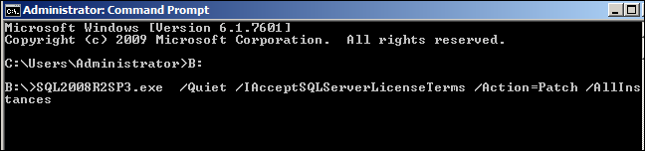

-- Below code applies SQL Service Pack SP3 for only Specific SQL Instance mentioned on the server.
SQL2008R2SP3.exe /Quiet /IAcceptSQLServerLicenseTerms /Action=Patch /instancename=SQLHyd

Prepared by - Praveen Madupu
Sr. SQL Server DBA
MB: +91-8197293434
whatsapp: +91-9866130093
Email: praveensqldba12@gmail.com Place: Hyderabad, Telangana, India.

